CST 238 Lab 2

Java Calculator

**Purpose**

1. Get practice using a Java GUI layout manager
2. More practice with ActionListeners

**Goal**

For this lab, you are to create a calculator application. The button layout should mimic that in the picture below. You are NOT required to get an exact representation of the calculator. The image is only supposed to show button location, function, and relative size.

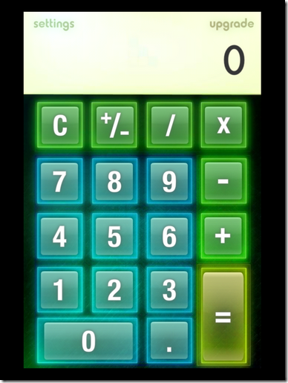

You will need to use a layout manager (I’d suggest GridBagLayout) so that your calculator will have the following behaviors:

1. As the user re-sizes the calculator, the buttons must stretch to appropriately fill the calculator.
2. The display (where the numbers go) should not stretch vertically.
3. OPTIONAL: Specify a min and max size so the buttons are always visible, but you can’t make the calculator too large.

The only interface to the calculator is the mouse (not the keyboard). You should not be able to type into the display, and you do not need keyboard shortcuts for the buttons.

For my implementation, I created the following classes:

1. Screen (subclassing JTextField). The screen kept track of the current number being entered, and the result following a calculation. I had the following methods:
   1. add digit – called when a numeric button was pressed
   2. get value – returns the current value on the display
   3. set value – sets the value following a computation
2. Number button (subclassing JButton). The number buttons behave the same except for the “value” of each button, so I chose to make a subclass.
3. Calculator (subclassing JPanel). This class contained all the buttons, the screen, and the layout. It contained the action listeners for the non-numeric buttons.

You do not need to follow my pattern, I only offer it as a hint.

**Thought process**

You can think of this lab as containing two problems: how to lay out the UI and how to get correct behavior. You can think of the two problems separately (although some decisions in one area will affect decisions in the other).

When you start thinking about correct behavior, I’d suggest you experiment with the “standard” Windows calculator. What, exactly, do the operation buttons do? What, exactly, does the equals button do? What, exactly, does the +/- button do? What information do you need to maintain in order to get this behavior? (Hint: you need more than just the information on the screen). Where should that information be stored?

**Grading**

Points will be awarded for the following categories:

1. Proper layout:
   1. The layout mimics the picture in this write-up (layout - not other appearance features).
   2. The layout behaves appropriately as the window is resized
2. Proper behavior:
   1. Each button behaves the same way as the equivalent button in the Windows Store calculator in “standard” mode.
   2. Calculations are done correctly.
   3. No surprises.
3. Appearance:
   1. Up to 10% extra points are available if you go beyond the standard appearance of the Java controls. Be creative, but don’t have your creativity detract from usability.
   2. Up to 20% extra points if you add a menu that you can use to change the appearance of the calculator. Examples: various skins or add a scientific mode.
4. Coding style
   1. Code has proper header comments.
   2. Code is easy to understand. When in doubt, explain in comments.
   3. Good programming practices were followed.